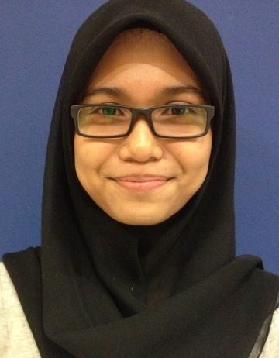

**NUR IZZATI BINTI IBRAHIM**

|  |  |  |
| --- | --- | --- |
| MAILING ADDRESS | | PERMENANT ADDRESS |
| Address: No 37 Jalan Suasana 1/2,  Bandar Tun Hussein Onn,  43200 Cheras,  Selangor Darul Ehsan.  Tel(Home): 03-90822544  E-mail: [nur_izzatiibrahim@yahoo.com](mailto:nur_izzatiibrahim@yahoo.com) | Address: No 37 Jalan Suasana 1/2,  Bandar Tun Hussein Onn,  43200 Cheras,  Selangor Darul Ehsan  Tel(Mobile): 018-3113192 | |

|  |
| --- |
| PERSONAL PARTICULAR |

|  |  |
| --- | --- |
| Age: 24 years old  Nationality: Malaysian  Marital Status: Married | Date of Birth: 5 August 1992  Gender: Female  IC No.: 920805-14-5760 |

|  |
| --- |
| EDUCATION BACKGROUND |

Education: SMK Cheras

Level: SPM

Higher Education: Diploma in Office Management

Level: Semester 5

Course Outline: Faculty of Business Management

CGPA : 2.81/4.00

Current Education: Bachelor in Human Resources Management

Level: Semester 1

Year: 2016/2021

EMPLOYMENT HISTORY

**1. Aura Roboclean (M) Sdn Bhd** *: November 2012 – November 2013*

Position Title (Level) : Personal Assistant cum HR

Specialization : Secretarial/Executive & Personal Assistant

Role : Secretary/Personal Assistant

Industry : Electrical & Electronics

Monthly Salary : MYR 1200

Work Description :

1. Handling the daily activities of the Director. This includes handling phone calls, meetings and appointments.

2. Apart from these responsibilities, I also demand to take care of small yet, important matters like managing the accounts, checking on the stationery, writing minutes, taking dictations and so on.

3. Many times, I am also expected to handle unofficial work of the Director.

4. Keeping the Boss updated about the recent updates like emails, letters and information of similar nature.

5. Preparing correspondence on behalf of the Boss.

6. Other related tasks which instructed by the Director

7. Handling ordered machines from AuraGMBH Germany for Singapore,Indonesia and also Malaysia distributor.

**1. Zaid Ibrahim & Co :** *: December 2013 – Present*

Position Title (Level) : Human Resource Executive & Secretary to Head - Group HR Director

Specialization : Secretarial/Executive & Personal Assistant/Human Resource

Role : Secretary/Personal Assistant/Executive

Industry : Legal Firm

Monthly Salary : MYR 3050

Work Description :

**Secretary**

* Provide efficient day to day secretarial and administrative support to Regional HR Director.
* Coordinate schedule, maintain appointment calendar, meeting and travel arrangements.
* Attend to any ad hoc assignments if necessary

**Recruitment**

* Assist in recruitment activities for attachment and trainee associate application
* Preparing offer letter for attachment and trainee associate
* Preparing interview schedule for TA committees
* Also, handle structured internship programme (July)
* Assist in reminding Partners/masters on the outcome (retain/non retain) for the chambering students

**Administration**

* Key new hire personal data in eHRM system.
* Ensure all personal files are updated on daily basis
* Handle immigration document for expatriates employee
* Updating telephone directory
* Updating photo gallery for Trainee Associates
* Maintain and update all personnel records are up-to-date
* HR updates for new hires.

**Welfare**

* Processing medical claims and clinic invoices
* Filing medical certificates and acknowledge receipts

|  |
| --- |
| SKILLS OR TALENTS |

|  |
| --- |
| * Keyboarding Skills. * Computer Skills. * Critical thinking, decision making and problem solving skills * HTML or Office Software Skills * Ability to handle an event. * Energetic. * Effective Listener. * Capable of controlling software Microsoft Word 2007, Microsoft Excel 2007, Microsoft Power Point 2007 and Internet Application. * Able to write in Malay and English Languages. * Communication ability in English with score 4/5. * Ability to work in team, helpful, can communicate well with other, ready to share ideas and concern for quality work |

|  |
| --- |
| LANGUAGES |

|  |  |
| --- | --- |
| Bahasa Malaysia: Very Good | Bahasa Inggeris: Good |

|  |
| --- |
| REFERENCES |

|  |
| --- |
| Upon Request |